Uphill Electron at 7/6 pi, gains energy from the MW field.
Launched at -20 GHz, Static = 14 mV/cm

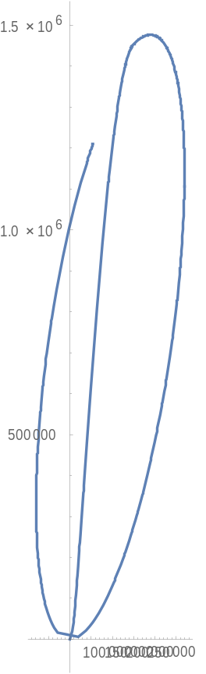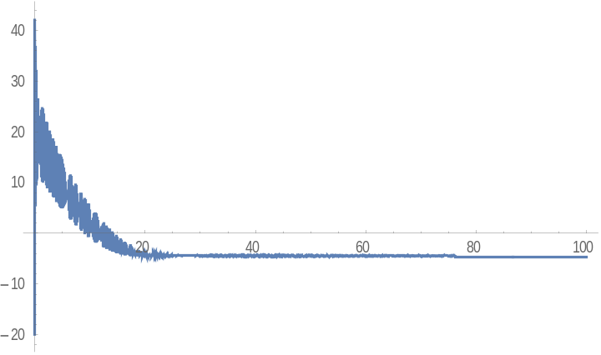
Downhill Electron at 7/6 pi, loses energy from the MW field.
Launched at -20 GHz, Static = 14 mV/cm

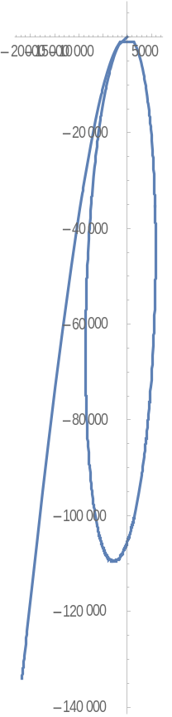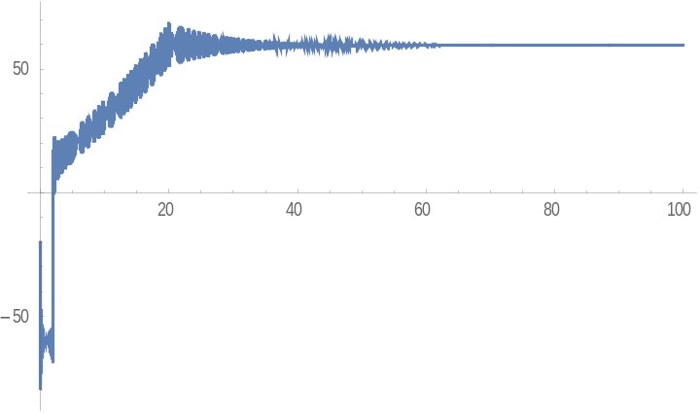
Uphill Electron at 1/6 pi, loses energy from the MW field.
Launched at -20 GHz, Static = 14 mV/cm

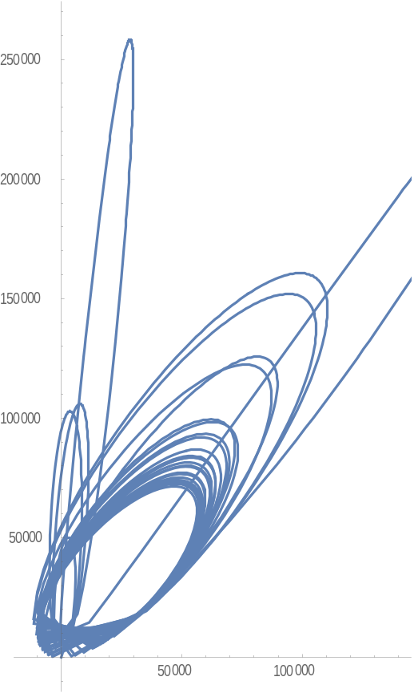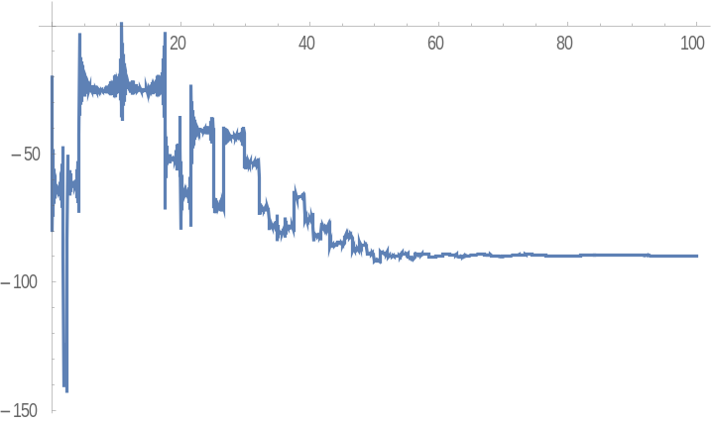
Downhill Electron at 1/6 pi, Gains energy from the MW field.
Launched at -20 GHz, Static = 14 mV/cm

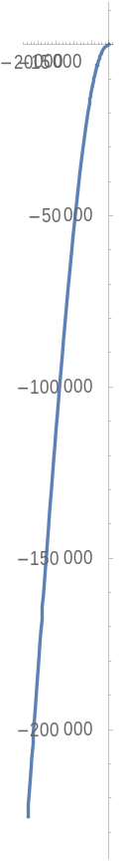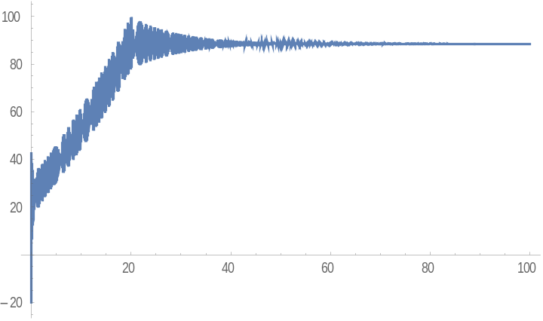
Uphill Electron at 7/6 pi, Gains energy from the MW field.
Launched at -20 GHz, Static = 100 mV/cm

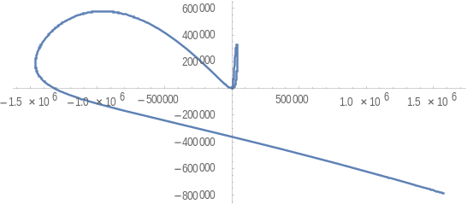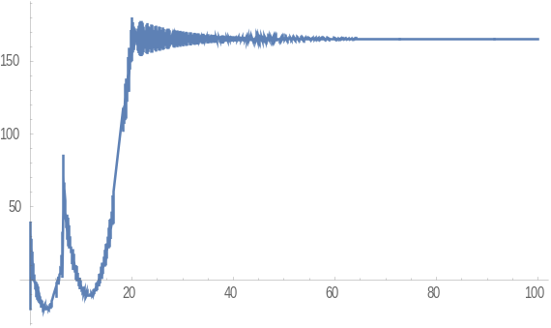
Uphill Electron at 1/6 pi, Loses energy from the MW field.
Launched at -20 GHz, Static = 100 mV/cm
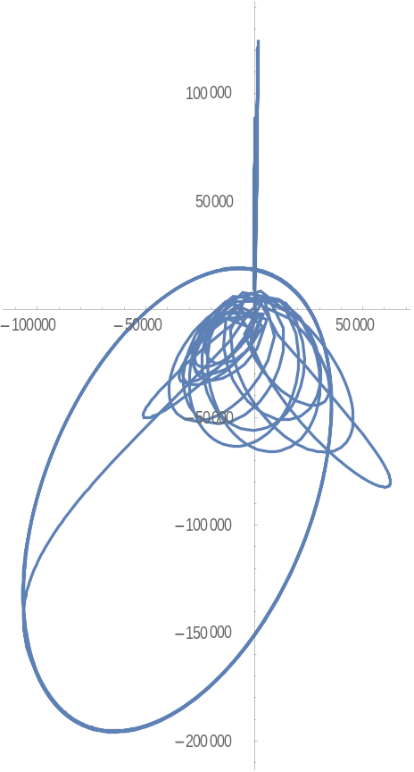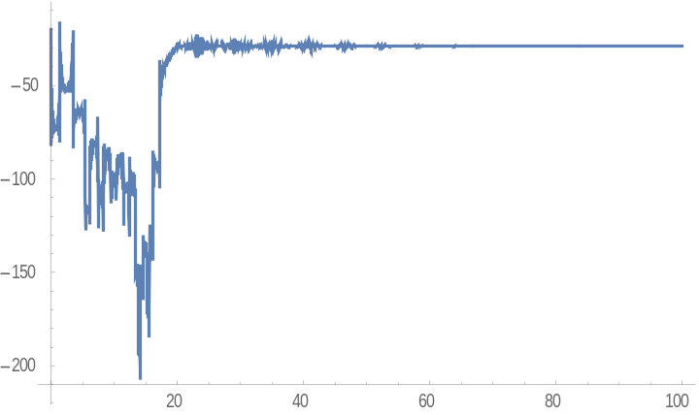
Downhill Electron at 7/6 pi, Loses energy from the MW field.
Launched at -20 GHz, Static = 100 mV/cm
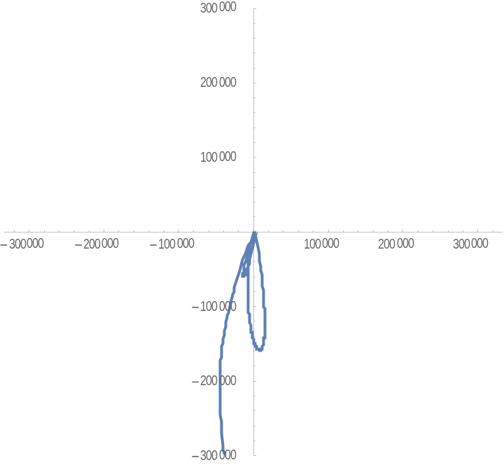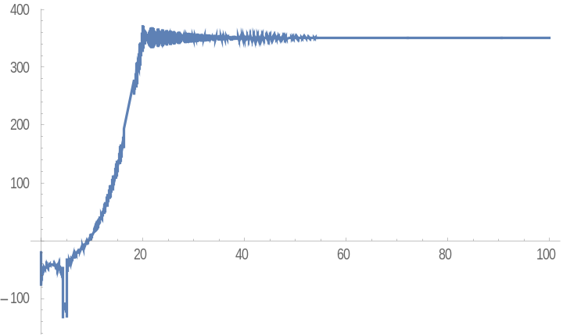
Downhill Electron at 1/6 pi, Gains energy from the MW field.
Launched at -20 GHz, Static = 100 mV/cm
